# Introduction

* Data Structure is a **way of organizing data**. So that it can be used effectively.
* Data Structure is the **representation of the logical relationship exists between the individual element of data.**
* Data Structure is **logical or mathematical model of a particular organization**.
* Data Structure is the way of organizing data items that consider not only the element store but also their relationship between each other.

**Note**- ***Which Data Structure to use*?** It always depends on the solution approach to resolve the problem. It never depends on the problem nor on the data.

There is only one data type which is integer. Data type depends on the line of abstraction that distinguished between datatypes.

As Floats are collection of integers. ( 5 4 . 6 9 (54.69) here 5, 4, 6, 9 belong to class of integer).

# Classification of Data Structure

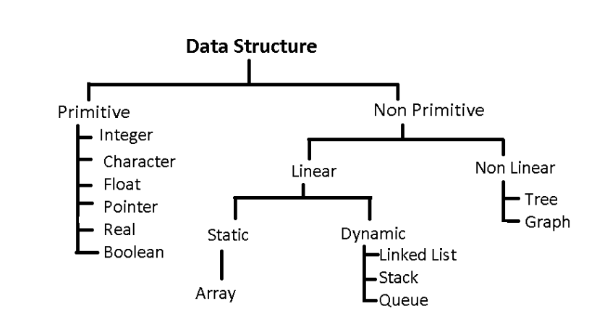

|  |  |  |
| --- | --- | --- |
| Data Structure | Linear | Non-Linear |
| Operations | Sequential | Random |

# Array

* Linear data structure
* Collection of similar data types
* Elements are stored in contiguous memory locations.
* Address of first element is known as base element and other elements are stored with a displacement of size of data type stored.
* Type – 1D, 2D, MD

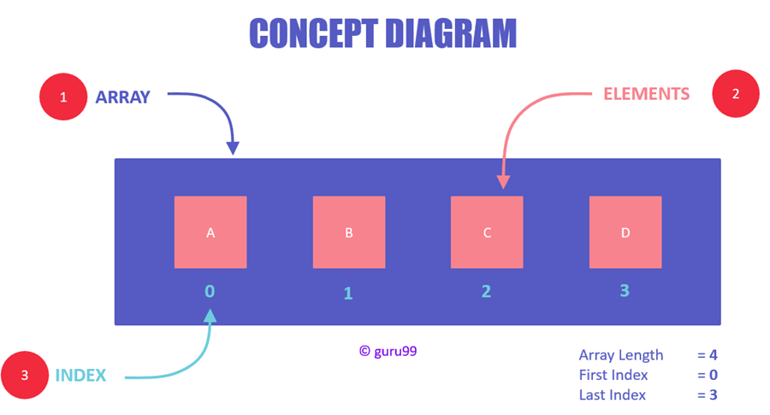

1D array

Note- Array doesn’t store the element value but it stores the address of the element.

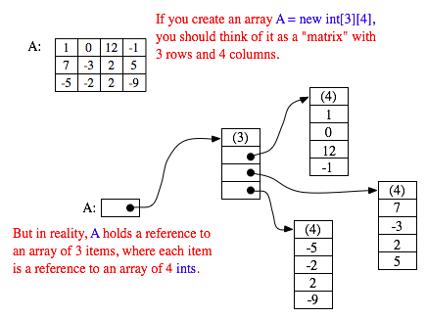

2D array

# Stack

* Linear data structure
* One open end and another closed end
* All operation is performed from opened end
* Uses LIFO (last in first out)
* The topmost element is pointed with a pointer called TOP
* Insertion operation is known as push and deletion as pop

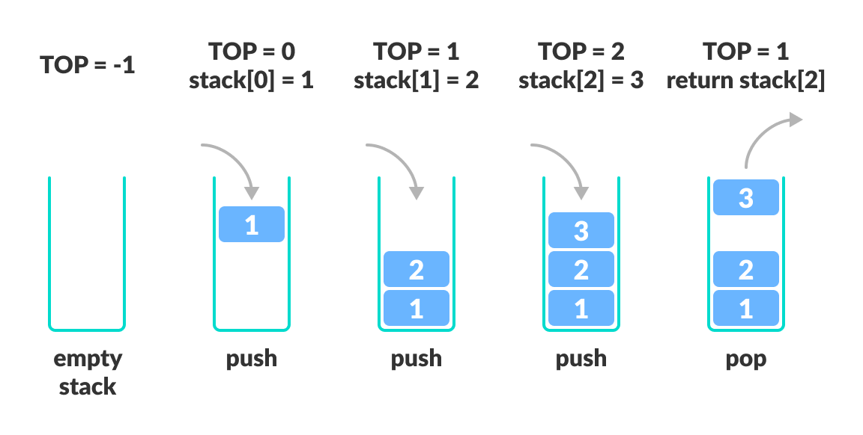

# Queue

* Linear data structure
* Both ends are open
* Uses FIFO (first in first out)
* It used two pointer FRONT and REAR
* Insertion (enqueue operation) are performed from rear and deletion (dequeue operation) are perform by front end

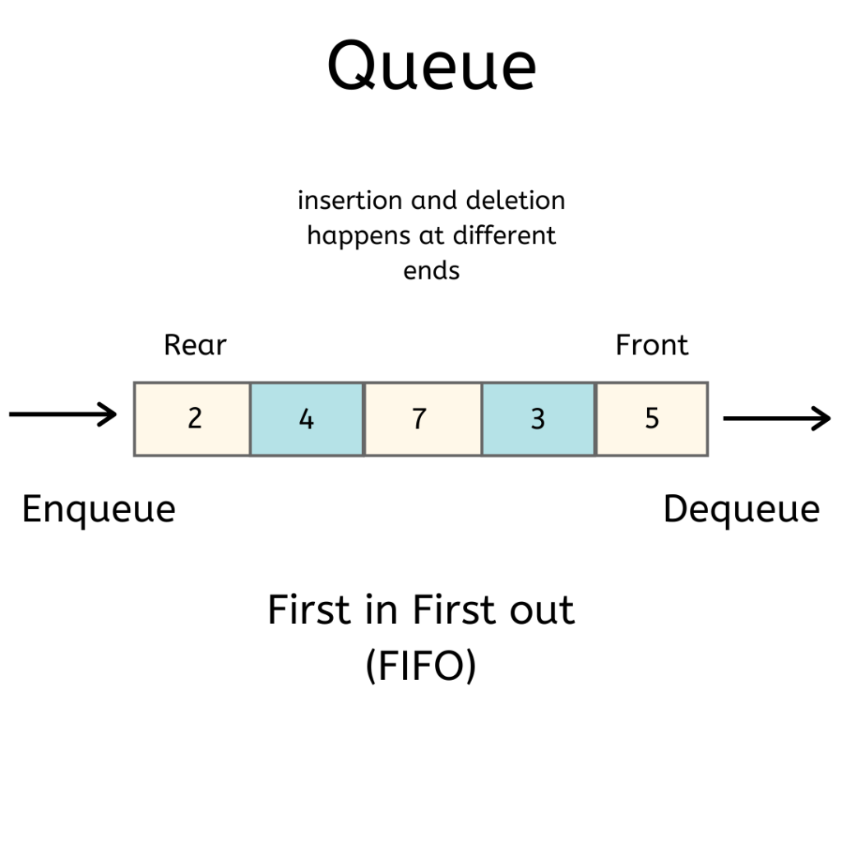

# Linked List

* Linear data structure.
* Element are stored inside nodes.
* Node contains at least two fields (1) Information/ Data (2) Address of next element.

